Moses Lake Classic Car Club
MLCCC General Membership Meeting Date: May 9th, 2024
Members in attendance: 34 (Thirty-Four)
Intersection of Grins & Giggles: Dave brought us back to our childhood days, asking us to recall and perhaps even “THANK OUR MOTHERS as we reviewed that time in our lives where we probably needed correction and discipline: Ten (10) HILARIOUS THINGS MY MOTHER TAUGHT ME ~~ asking for a show of hands if we had ever heard such admonishments. The point was that “MOTHER TAUGHT ME” as we celebrate “MOTHER’S DAY in just two days, on May 12th, 2024. Things that were perhaps unpleasant at the time for us, but certainly helped guide us into our adult years as we can testify by being here tonight. Mother Taught me: To appreciate a job well done / Religion (You better pray that comes out of that carpet) / Time travel / Logic (Because I said so) / Foresight (Make sure you wear clean under – you know why?) / More Logic / Irony (Keep crying – and I’ll give you something to cry about) / Contortionism / Stamina (You’ll sit there until you eat all of that spinach and it’s gone). “Thanks Mom”.
Meeting Called to order: 7:04pm/pdt (Bob’s Restaurant – Moses Lake, WA)
By President: Dave Robins “Thank you for being here tonight” (Decorations By: Ann Robins – May Flowers) . NOTE: This is the sixth (6th) General Meeting of MLCCC’s 24/25 Fiscal accounting year (Not Calendar Based). Dave - “So I declare ….” Let the fun begin as we proceed through a very busy month of May’s activities”.
Pledge of Allegiance: (The American Flag - Stars and Stripes – In God we Trust)
Welcome guests: Dave greeted returning members from long past - one re- joining in active membership.
Secretaries’ Report: Note: MLCCC’s Exec. BOD gave Vicki Family Leave tonight to enjoy visiting family. Dave asked if attending members wanted the minutes of last meeting held on April 11th, 2024 read (or) by show of hands would dispense the reading and asked for motion of approval as posted on the WEB-SITE? Motion to approve (Tom Carlton) and seconded by Marcy Ostenberg – Motion passed as approved.
Paper copies can be mailed directly to you upon your request (Snail U.S Mail (or) E-Mail, See Paul.
Treasures’ Report: Bob Kent submitted his financial review. As of April 1st, 2024 Balance: $ 7,797.00. He also reminded us that some outstanding dues need to come in yet / Some original MLCCC caps for sale. He also reported that MLCCC’s Risk Insurance premium has been paid (Actually came down)! All other bills have been paid and we are current on all accounts. (Copies are also available upon request)
Web Master Report: Paul Boehm was also given the night off for his annual short R & R camping trip. However, Dave reminded us of the “GREAT JOB Paul does with keeping current on both lines of inner club communication: moseslakeclassiccarclub.com and by full membership E-Mailing / texting. Please be sure and keep consulting our own web pages for “What’s Next” on our activities schedule – Don’t miss out! ! !
Acknowledgements: (Anniversaries) Nobody present acknowledged (Birthdays) Dennis Jackson??

Rear View Flashbacks: Karen Crook Reported that the “Duck Award” was still being cared for by Charlie. He had been reported as having been faithful to our “DUCK CUSTODY RULES” at the last Sunnyside Car Show. Karen also invited us all to share in her late husband’s (CLAY CROOK’s) Memorial Celebration of Life.

~ ~ July 21st, 2024 - 2:00pm at her home (431 West Northshore Drive, Moses Lake, WA 98837) ~ ~

Page 1 of 3 Pages

Planned Events & What’s Next : Dennis Jackson gave a review by Names // Dates // Times for upcoming events to schedule and look ahead when marking your MLCCC FREE CRUISIG SEASON ( June through October ) Be sure and watch the MLCCC Web-Site Flyers // E-Mails // Phone Texting // Person to Person to schedule. The Month of June will be very active also: June 8th, Wilson Creek Car Show // June 15th, 2024, Brent Reese Memorial Car Show – Scotty’s Parking Lot // June 16th, 2024, Camas Cove Cellars // Keep watch Boys and Girls – Recording combined milage for year-end totaling and our 2024 history lock as having accomplished.
Unfinished Business : Dave Reminded us all that our very active month of MAY was well underway . Again, reminded us to get in the habit of our newest program: MLCCC’S COMM = CENTER = LINE, simply by CRUISING THROUGH OUR WEB – SIGHT for latest happenings. Moseslakeclassiccarclub.com
Dave also updated us on MLCCC’s upcoming involvement for May events in our community Outreach.
May 11th, 2024 - (Some involved in the “SALUTE TO OUR VETERANS PICNIC” – Quincy, WA May 15th, 2024 - Mc Kay’s Health Center Show & Shine ~ Soap Lake, WA (Check E-Mail Flyer)
May 18th, 2024 - ANNUAL CRUISE TO HARRINGTON, WA- Hosted by the STUDEBAKER GARAGE
May 24th, 2024 - Our Own FIRST CRUISE NIGHT OUT in MOSES LAKE w/ City Cruising Route.
~ ~ Supporting Moses Lake’s 44th Annual Spring Fest Celebration ~ ~.
MLCCC BOD & ADVISOR’s now announcing that most all details // pre-planning // arrangements // etc., are now in place and it’s your turn to find out where you can add to our success. We are sending a clip board around tonight for you to identify with a named task group and a BOD member to whom you will report / time, etc. Just sign your name / phone number and we’ll be in touch as your task becomes active. “Thank you in advance” ~ we will need about 23 people to guarantee our success and still have our fun.
New Business : Dave took questions and give detailed answers to those present . Also reminded them that this would be their last chance to make in club (first come first serve) purchase of MLCCC’s Special Event Tee- Shirts – designed especially for our “CRUISE NIGHT OUT” ~ ~ MAY 24TH, 2024 ~ ~ 4 TO 10 PM. We have them here and available tonight at $ 25.00 each while they last - rest to be sold on the night of the event. This is a FUND RAISER ~ proceeds going to CARS, COPS & COFFEE – BLUE SHIELD.
Door prize drawings : Judy conducted the drawing again and the winners were ?
Tim Jones - Item not identified.
Sorry, lost track of others / be gentle with us – it could have been you!
Car of the month : Judy Jeff Isaak - 1994 Pontiac Firebird ( See story and photo attached )
50 – 50 Drawing : Judy Winner tonight ~ Ray Roeder ~ Amount $ 42.00 ( = 10.8 Gall of gas at $3.89 current price )
For the good of the cause : Dave Remember your mother on Sunday, May 12th, 2024 ~ if you’re blessed to still have her ~ she needs a big hug ~ if she already passed, be thankful, she’s the one who potty trained you with so much love ~ and as we age, now it will have to be somebody else . (Think about it?)
Next General Membership Meeting here at Bob’s Restaurant ~ ~ Business Meeting 7pm – October 10th, 2024.
Motion to adjourn : Dave called for motion to adjourn – 1st Jeff Cobb // 2nd Judy Kent - Approved

Dave Closed: Motto: “Good Night” ~ ~ “Be Safe “~ ~ “No Road Raging “~ ~ “Enjoy Your Ride” Adjourned at : 8:10pm/pdt
Page 2 of 3 Pages- DR

May 2024 Car of the Month
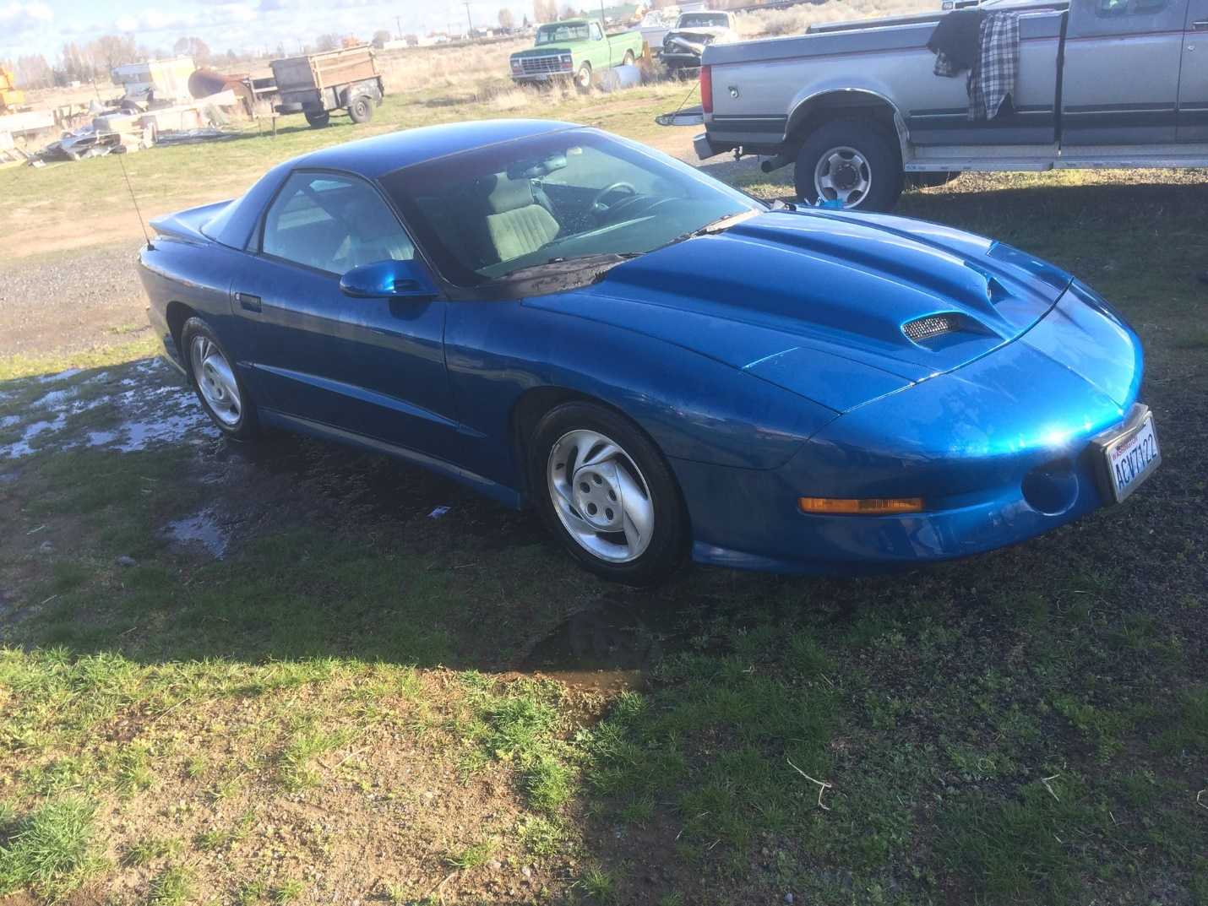
Jeff Isaak – 1994 Pontiac Firebird
I bought this car for $500.00 with a blown engine.
I found the same year engine from the guy who owns AL’s Glass, and it only had 34,000 miles on it.
I bought the engine for $600.00.
I hated the Firebird Rims, so I bought some Camaro rims for $300.00.
The car just turned 30 years old, so it now has collector plates on it.
When this car was new it could beat the Corvette.
It has a button for the transmission that you push if you want racing performance!
It came with two hoods, one factory and one Ram Air intake.
I liked the Ram Air Hood better.
I figure if you get a car that is as fast as a Covette for only $1,500.00, heck I did good.
Page 3 of 3 Pages- DR

